Frederick Brehm

7/2/2024

CS 330

Southern New Hampshire University

1. Included screenshot of the running OpenGL code displaying bottle of wine, cheese, and bread.

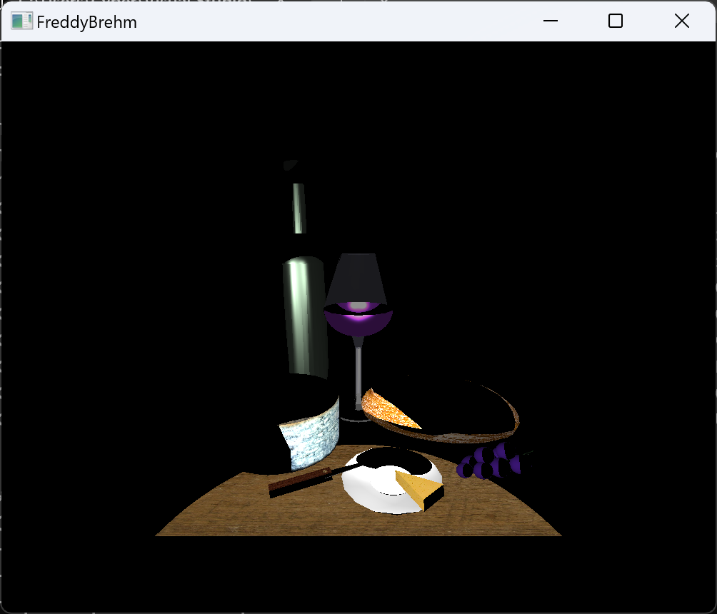

2.

This assignment was very well put together and organized. In my other classes I have never had a folder already in place that contains the projects and assignments for the entire semester. This will help as in the past I have struggled with starting projects completely from scratch. I have gained a better understanding of how to do so over previous classes but still struggle at times. There would be times where I did not include the correct build path or was running the project as a maven project instead of as a java application, but these were never instructed in the directions, so it became confusing. Already, the information and directions on this course are far superior then others.

As of this module and this assignment I have had no challenges. The directions on how to download visual studio were very clear, the only challenge I would try to elaborate on is what workloads are necessary for the installation. I did not see where it said specific workloads to install so I ended up installing all of them which I doubt I needed.

Once downloaded and installed I followed the directions for where to extract the file for CS330 in the C drive, and then opened “OpenGLSample.sln” in visual studio. I changed the name in the instructed code for the window box and then ran the program. Everything ran smoothly and the picture of the bread, cheese, and wine displayed with the name change at the top of the window.